**Criterion A: Planning**

My client

My principal client is my father, who works in marketing and design. He uses a laptop for most of the time when he is working. His typing speed is very poor and so he is looking to improve his typing speed, as it can improve digital productivity by a huge amount, depending on the task.

My proposal

I will be making a program which can be ran on his laptop. It will be programmed in python and will be able to be downloaded for offline usage. It will consist of multiple modes, which all promote fast typing, consisting of displaying a word and the user having to type it out in a text box within a set time limit. These modes may include speeding up the time limit to type the words in, suggesting longer words and suggesting words which the user has done poorly at typing. The user’s scores will be displayed at the end of each section for the user to see how well they did.

My prototype

I created a prototype using python which would allow my client to see how the program would look and feel. I have chosen to use python for my program, as it is a simple language to use, which I have been studying and thus have lots of experience in. I have also chosen to use the python module “tkinter”, as it allows for easy, simple GUI creation, which I also have experience in using. The prototype currently suggests a random word out of 15, allows the user to type it in the box and press enter to get the point. They have to do this within a set time limit, and if they do no then they miss the point for that word. After all 15 words have been answered then the user will get a score out of 15.

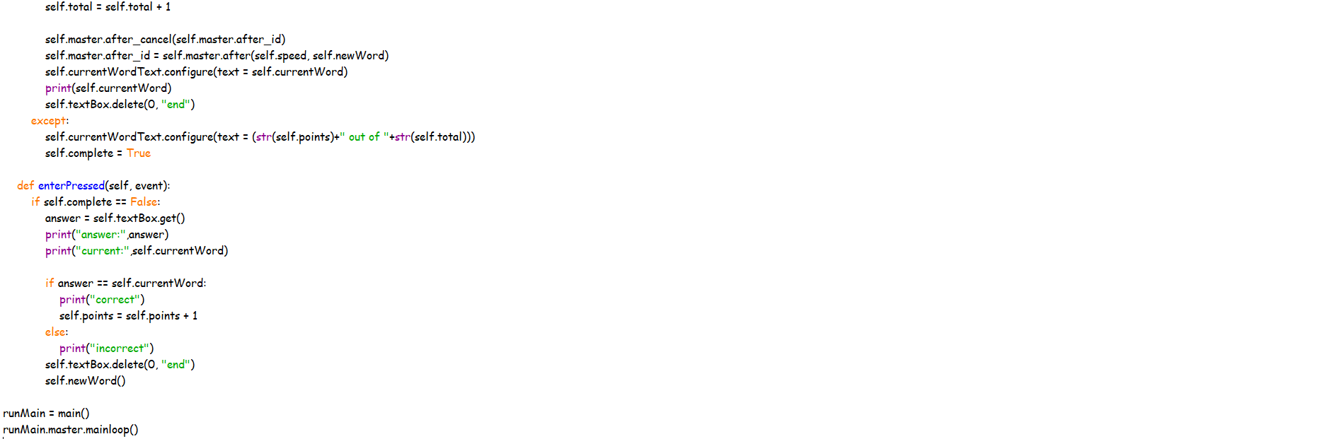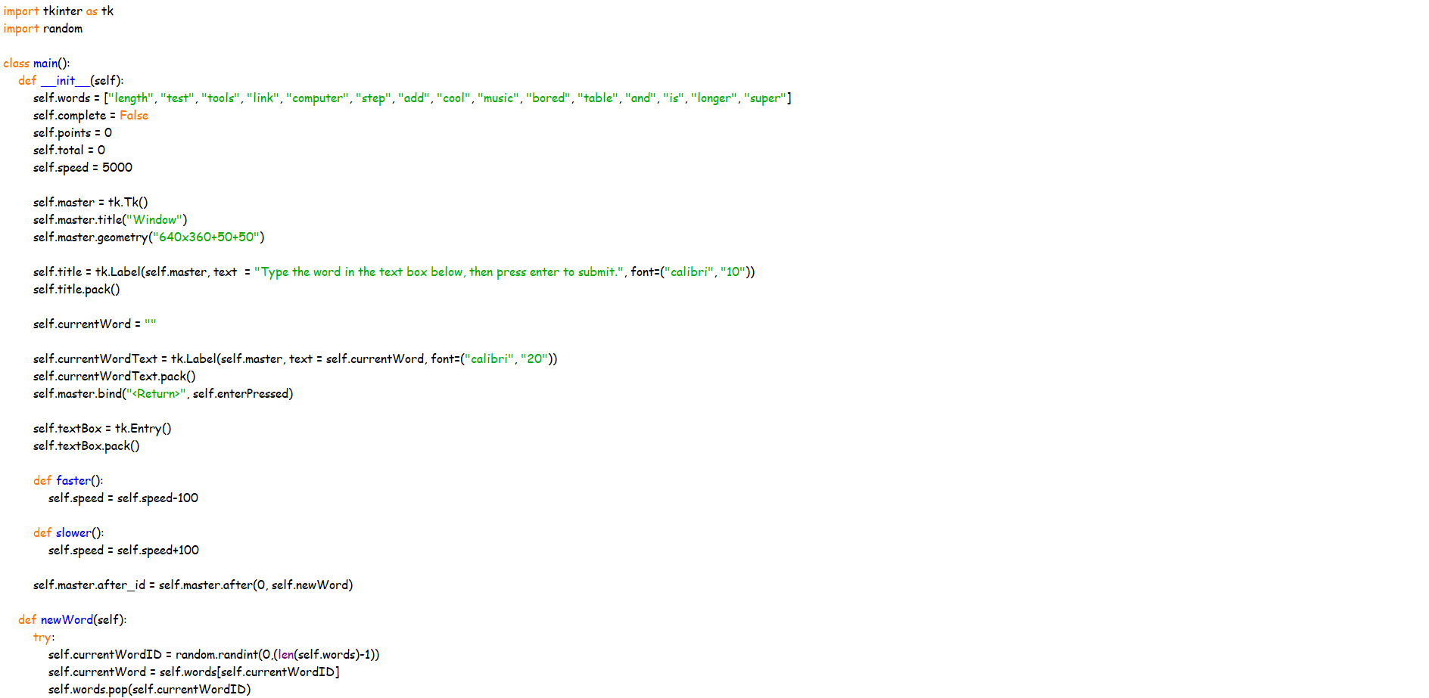

Client feedback

I showed my client the prototype that I had made (full interview can be found in the appendix) and, after having interviewed him on my proposal, he gave me the following feedback of features which he would find important:

* It should be a downloadable program as opposed to a web based one
* A simplistic GUI would be important
* The ability to see how you have improved over time should be implemented
* Different users should be able to log into the program to keep their data separate
* Users should be able to compare their scores

Success criteria

* Allow different users to create accounts and log into them
* Allow the user to choose different modes to practise their typing (speed or accuracy focused)
* Take user input from their keyboard
* Recording which words/letters they get right/wrong the most
* Able to suggest words/letters more often if the user gets them wrong a lot
* Show the user which words/letters they are best/worst at typing
* Show the user how they have improved over time
* Allow different users to compare their scores with each other